**Artificial intelligence:** Artificial intelligence (AI) refers to the simulation of human intelligence in machines that are programmed to think like humans and mimic their actions.

**Machine Learning:** Machine learning is an application of AI that enables systems to learn and improve from experience without being explicitly programmed

**Difference between Machine learning and Deep Learning: ML** means computers learning from data using algorithms to perform a task without being explicitly programmed. **DL** uses a complex structure of algorithms modeled on the human brain. This enables the processing of unstructured data such as documents, images and text. Machine Learning is a type of Artificial Intelligence.

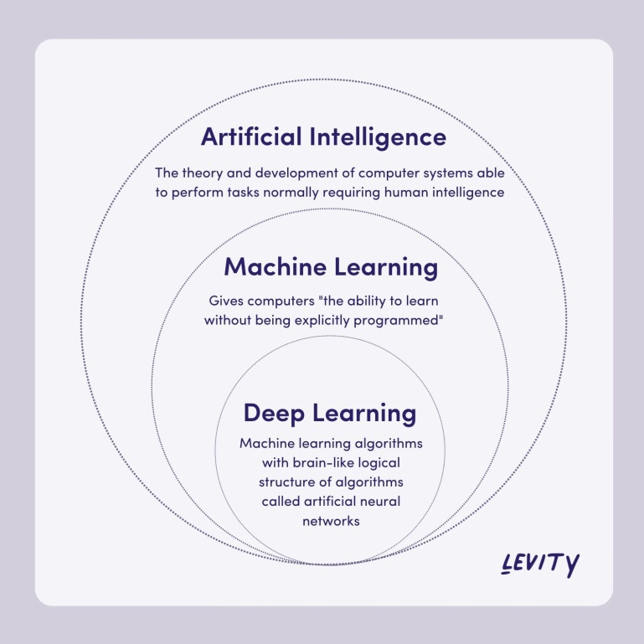

**ANN**: (ANN) is a computational model that consists of several processing elements that receive inputs and deliver outputs based on their predefined activation functions.

**CNN**:  is a class of neural networks that specializes in processing data that has a grid-like topology, such as an image

**Weights**:  Weight is the parameter within a neural network that transforms input data within the network's hidden layer.

**Bias**:  It is an additional parameter in the Neural Network which is u**sed to adjust the output along with the weighted sum of the inputs to the neuron.** Thus, Bias is a constant which helps the model in a way that it can fit best for the given data.

**Activation function:** Defines how the weighted sum of the input is transformed into an output from a node or nodes in a layer of the network.

**Padding**: To maintain the dimension of output as in input , we use padding. Padding is a process of adding zeros to the input matrix symmetrically.

**Pooling**: technique for generalizing features extracted by convolutional filters and helping the network recognize features independent of their location in the image

**Perceptron**: A Perceptron is a neural network unit that does certain computations to detect features or business intelligence in the input data.

**Hyperparameters**: They are the parameters that are explicitly defined to control the learning process before applying a machine-learning algorithm to a dataset. These are used to specify the learning capacity and complexity of the model.

Parameters in machine learning and deep learning are the values your learning algorithm can change independently as it learns and these values are affected by the choice of hyperparameters you provide.

Learning rate is a configurable hyperparameter used in the training of neural networks that has a small positive value, often in the range between 0.0 and 1.0. The learning rate controls how quickly the model is adapted to the problem.

Back-propagation is the essence of neural net training. It is the practice of fine-tuning the weights of a neural net based on the error rate (i.e. loss) obtained in the previous epoch (i.e. iteration). Proper tuning of the weights ensures lower error rates, making the model reliable by increasing its generalization.